June 2021 NEWSLETTER
A Message from Reverend Greg

We are almost there! We are almost to the point of declaring victory over COVID 19. However, this is not about a victory. This has been one of the ghastliest pandemics in the history of the world, and still, there are areas of the globe where this can hardly be declared a victory. Many lives have been lost world-wide and people are still grieving, even while some parts of the world begin to return to some degree of normalcy.
For us at St. Stephen’s, we are moving cautiously forward and anticipate that by the Fall, we will be completely open again. So, where do we go from here?
First, we hold on to the good things we learned during this pandemic. As I mentioned in my sermon on Pentecost Sunday, I would encourage you to reflect deeply on what you learned during this pandemic, clinging to the good things that carried us through these past months. One thing is certain: we discovered Zoom and learned how to use it for communal prayer and meetings/gatherings. Often times I would hear, “I am so tired of Zoom!” And rightfully so but let us not forget that it was Zoom that kept many of us together.
Secondly, we rediscovered that “church” is not the building...it is the people of God and church is wherever we are gathered. We learned that we, the church, can function even in the harshest of circumstances.
Thirdly, we proceed slowly and cautiously. COVID 19 has not vanished from the face of our planet; it will be with us for a long time. However, we have, through the gift of science and medicine, vaccines that can keep people safe. Our mask wearing and distancing have never been about taking away our rights; it has been about our care for one another and the need to keep everyone safe. Slowly, as masks are removed and no longer required, remember good hygiene and best practices between one another. However, we are not there yet! Masks will continue to be required in order to attend services at St. Stephen’s until further notice.
Yes, we are almost there, and we have learned much during this pandemic that will serve us well in the future. We, the people of God, are regrouping and we do so with much gratitude to those who protected us during this pandemic and to those who had no choice but to go to work rather than work from the safety and comfort of home. We regroup realizing that some are missing, and our hearts are still sad. We regroup not to old ways, but to new life and new ways.
Pentecost Sunday: Our first time together in person and the joyful
baptism of Matthew Breckenridge!

SUNDAY WORSHIP, 10:00 AM

How to Watch
Tune in to join Sunday Services, Live weekly at 10:00 am ET right here on our website, on the St. Stephen’s YouTube Channel, or via the YouTube App on your phone, tablet, or Smart TV.
Subscribe to the St. Stephen’s YouTube Channel to easily find this broadcast on your YouTube App on any device. After setting your reminder, simply open the YouTube App on your Smart TV, tablet, or phone and log in with the same Google/YouTube account to see the scheduled broadcast.

Watch With Others
If you’d like to join other remote congregants to watch the broadcast together, we’re hosting a Zoom Meeting where congregants can see one another while watching. Additionally, join a few minutes before 10:00 am or stay after the service ends to chat live with other congregants.
You can join the Zoom Meeting using this link and using the passcode previously provided to all congregants. If you need help, please email ststephens@ststephenslynn.org.

REST IN PEACE, DEBORAH LYNNE POTTER
October 2, 1949 – May 21, 2021
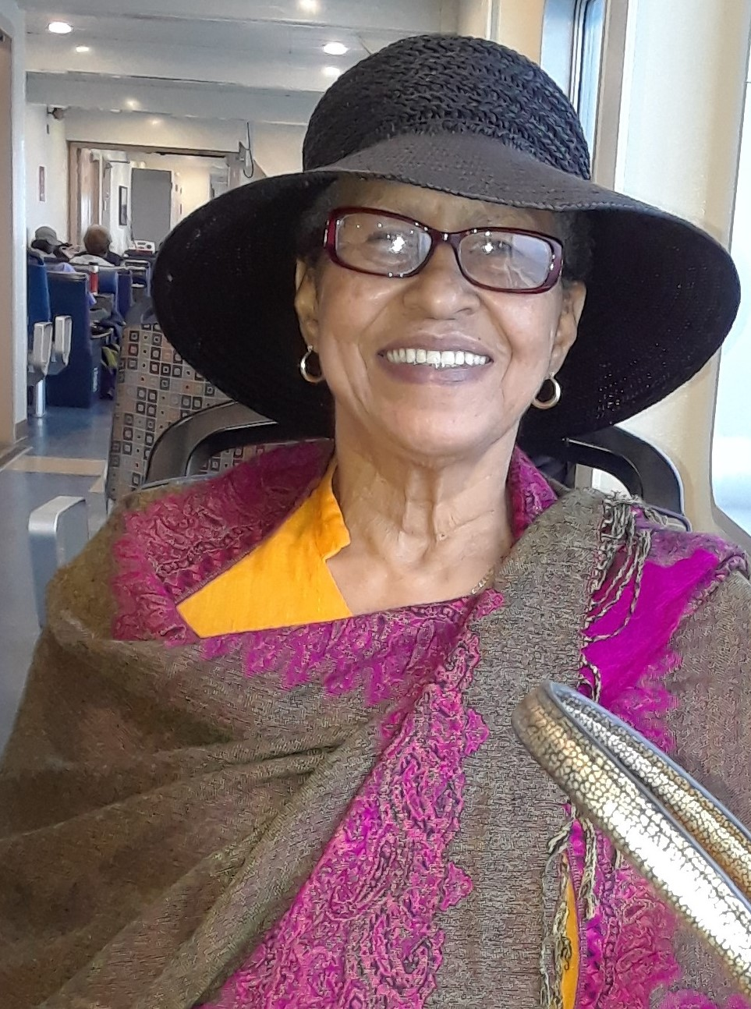

Born October 2, 1949, the youngest of 7 siblings. Deb transitioned on May 21, 2021, after losing her multiyear and courageous battle with cancer.
Deborah was the daughter of the late Charles William Bradley of St. Louis/Alton IL and Florence Mae Fowler of Nova Scotia. A Lynn resident, Deb attended the Callahan and Burrill schools, graduated from Lynn Classical in 1968 and went on to attend Salem State College and Boston University. Deborah was a faithful member of St. Stephen’s Memorial Episcopal Church in Lynn.
Employed by Digital Equipment Corp/HP Roxbury, Deb worked as a Financial Analyst and operated the plant-wide Payroll & Corp. petty cash. Worked at GE and Lynn Police. Was involved with the Curwin Circle Park and Recreation Program, and was creative assistant to Betty Downes, who owned the Designer Shop. A Runway Model for Dept. Stores in ‘80’s’ - Lechmere, Filene’s.
Deborah served on the City of Lynn Democratic Committee, the MA Governor’s Task Force for Raising Minimum Wage, was a member of ECCO (Civil and human rights), St. Stephen’s Pastoral Care Team, Choir member, former Vestry member, Eucharistic Minister.
Deborah was married to Jesse Timothy Potter (1984) from Indianapolis, and she is survived by him and her sister Carol Smith, of Lynn.
Children and their spouses: Tiffany Bradley (Michael Fleuriel, Sr) of Lynn; James Edward Bradley (Elisha C. Bradley) of Salem; Jesse T. Potter, II, of Lynn.
Grandchildren: Michael Fleuriel, Jr., Felicia Fleuriel, Travis Fleuriel, Maiyah Fleuriel, and Gianna Fleuriel; Jailen Bradley, Jaiden Bradley, Jaicob Bradley, and Jaiziah Bradley. Deborah is also survived by a great grandchild, Elijah J. Shields and a host of nieces, nephews/great nieces & nephews in several states.

BIBLE STUDY: St. Paul’s Letter to the Romans

Bible Study meets on Zoom each Wednesday at 6:30 PM to explore Paul’s Letter to the Romans. If you are interested in joining the group, please reach out to Rev. Greg for the Zoom link at gperez@ststephenslynn.org or 781-599-4220, Ext. 2.

FOOD PANTRY NEWS

With support from the Boston Food Bank, and other benefactors, the Food Pantry has purchased a new commercial-grade equipment, a refrigerator and a freezer, along with three new carts that will help the Food Pantry safely manage the food supply for Pantry patrons. Come check out the newly reorganized pantry! We meet Thursday at 11:00 AM to assemble the bags and on Friday from 2-4 PM to distribute them (every week EXCEPT the first week of the month). You can also come to help unload the truck on the second Friday of the month at 11 AM. WE STILL NEED DRIVERS: Once a month, a driver and a helper are needed to pick up our food orders from the Greater Boston Food Bank. If you know anyone who’d like to make a little extra money and help get food to people in need, please call the office.

THE WOMEN’S GROUP
The Women’s Group is an opportunity for fellowship for women from St. Stephen’s and St. Andrew’s. We meet on the second Sunday of the month, from 12:30 to 2 PM. To get the Zoom invitation to join the meeting, please contact St. Stephen’s office.

BELOVED COMMUNITY TEAM

The Beloved Community Team is a multiracial group of men and women from St. Stephen's and from St. Andrew's in Marblehead learning from each other and supporting each other to personally unlearn racism and to work to change racist policies and structures. We have had some new members join us, so we will be spending some time getting to know them and they us. We are always unfolding with new surprises even for those we have known for some time! So if you have never come to BCT meeting now would be a great time to join. We meet once a month, on the 2nd Thursday of the month, from 7-9 PM. If you'd like to get on the email list for BCT, please email Pam Poppe at pamelapoppe61@gmail.com

KIDS IN COMMUNITY

Kids in Community Summer Program is now enrolling children in grades 1 through 6. Camp starts on July 12 and runs for four weeks and is free, except for a registration fee of $20. Families can sign up now by contacting the Church Office for a registration form. We will also be hiring Mentors and Group Leaders. Anyone interested or with questions should contact the KIC Program Director Shannon Morrissey at (781) 599-4220 or smorrissey@ststephenslynn.org

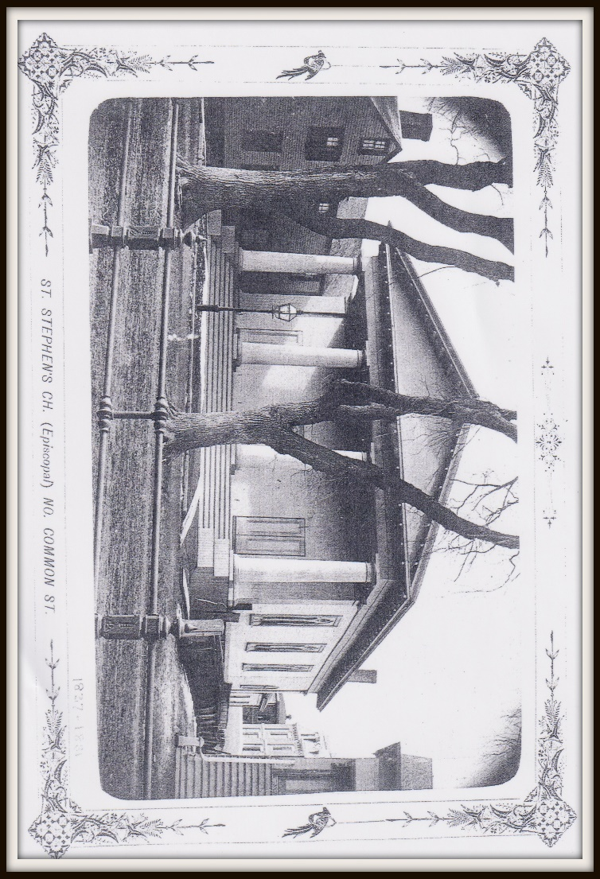
A LITTLE BIT OF ST. STEPHEN’S HISTORY
Excerpted from St. Stephen’s 100th Anniversary Book - 1944
The original “St. Stephens” on the North Common St. site of the old Classical High School.

Adverse conditions kept the Episcopal Church out of Lynn till 1818. In October of that year some members of a Congregational Society, and not happy in that group, invited Rev. Thomas Carlisle of Salem to preach in the Old Tunnel Meeting House (later the site of the First Church [Congregational]). Mr. Carlisle naturally used the Book of Common Prayer in this occasion, which was probably the first Episcopal service in Lynn.
Early in 1819 the group which arranged this service, calling itself St John’s Church, met for worship in Academy Hall on South Common. The group must have accepted Church doctrine and ritual with reservations, for we find their leaders (clergy not always being available) freely adding to and subtracting from the church service. Mr. Carlisle and Bishop Griswold initially intended to discipline the group but instead advised them to give up a church name and use of the Prayer Book, which they did, becoming the first Unitarian Society of Lynn.
In 1834, Bishop Griswold became aware that two young men, Edward S. David and John Bowler, were regularly walking to Salem or Marblehead to attend church. With the Bishop’s help, a group was assembled in the fall of 1834 in Liberty Hall on Market St., to form a planning committee for a church in Lynn. They met regularly for worship from January till September 1835, when services were suspended for lack of funds. From January 1836 to May 1837 the Rev. Milton Ward ministered to this pioneer band in Masonic Hall, when a fire destroyed the hall and what small churchly property it had acquired.
Meanwhile, however, the future had looked bright enough to warrant the building of a modest church on North Common, and in July 1837, it was consecrated, with great joy as Christ Church. There was a school of ten pupils and worship continued unbroken through hardship and discouragement until January 1841, when the property had to be sold to another religious body. Services ceased, but not the hopes of the faithful leaders.
In 1844 Lynn was a summer home for many Episcopalian families. These felt the need of their own service, and joining with the loyal Christ Church band, organized September 1844 under the name St. Stephen’s, and raised funds to buy back their old church building.
To Be Continued…
DO YOU KNOW SOMEONE WHO NEEDS A CALL FROM THE CHURCH?
If you know someone who’s feeling the loss of community and connection with St. Stephen’s, please contact the office to let Rev. Greg or Brandi Walker know.
GET THE NEWSLETTER FASTER, AND SAVE POSTAGE AND PAPER…
Email or call Brandi to update your email address and ask for newsletter to be emailed to you each month! Brandi can be reached at (781) 599-4220 Ext. 5 or ststephens@ststephenslynn.org

ST. STEPHEN’S PHONE SYSTEM HAS BEEN UPDATED!
When calling the main number, you will hear an introductory message, followed by a directory so that you can leave private messages for Rev. Greg Perez (#2), Parish Administrator Brandi Walker (#5), the Treasurer (#3), KIC Program Director, Shannon Morrissey (#4) and General Mailbox (#1).
(Keep this handy – save time by dialing the extension number during the opening message!)

St. Stephen’s June 2021
Sunday | Monday | Tuesday | Wednesday | Thursday | Friday | Saturday
 |  | 1 First Day of LGBTQ+ Pride Month  Scholarship deadline  11:00 am Potter Funeral  11:00 am staff meeting | 2 ECCO Invoice  quarterly treasurer report  11:00 am Bruce Music Meeting  6:30 pm Bible Study | 3 | 4 Movie | 5
6 Second Sunday after Pentecost:Proper 5  10:00 am Holy Eucharist - English | 7 Movie  Sabbath Rest (PIC) | 8 Movie  11:00 am staff meeting | 9  11:00 am Bruce Music Meeting  6:30 pm Bible Study | 10 | 11 St. Barnabas  2:00 pm Food Pantry | 12
13 Third Sunday after Pentecost:Proper 6  10:00 am Holy Eucharist - English  10:00 am Scholarship Sunday  12:30 pm Women's Group | 14 Sabbath Rest (PIC) | 15  11:00 am staff meeting  12:30 pm Virtual Clergy Development Day | 16  11:00 am Bruce Music Meeting  6:30 pm Bible Study | 17  9:00 am Virtual Hispanic Commission Ministry  1:00 pm Virtual Support Group for COVID Clergy & Bishop | 18  2:00 pm Food Pantry | 19 Juneteenth
20 Father's Day  Fourth Sunday after Pentecost:Proper 7  10:00 am Holy Eucharist - English | 21 Sabbath Rest (PIC) | 22  11:00 am staff meeting  6:00 pm Virtual Executive Committee Meeting | 23  11:00 am Bruce Music Meeting  6:30 pm Bible Study | 24 Nativity of St. John the Baptist  12:30 pm Virtual ECCO Clergy Meeting | 25  2:00 pm Food Pantry | 26
27 Fifth Sunday after Pentecost:Proper 8  10:00 am Holy Eucharist - English  12:30 pm Vestry Meeting | 28  Sabbath Rest (PIC) | 29 Saint Peter & Saint Paul  11:00 am staff meeting | 30  11:00 am Bruce Music Meeting  6:30 pm Bible Study

